Computer Networks Lab 6
The University of Azad Jammu and Kashmir

Course: Computer Networks
Course Code: CS-2203
Lab No: 6
Submitted To: Engr. Asma Javaid
Submitted By: Momina Imran
Roll no : 2024-SE-33

Objective
This lab demonstrates the basic Cisco router configuration process using Cisco Packet Tracer.

Step 1: Open Router in Cisco Packet Tracer
Launch Cisco Packet Tracer, place a router on the workspace, and open its CLI tab to begin configuration.
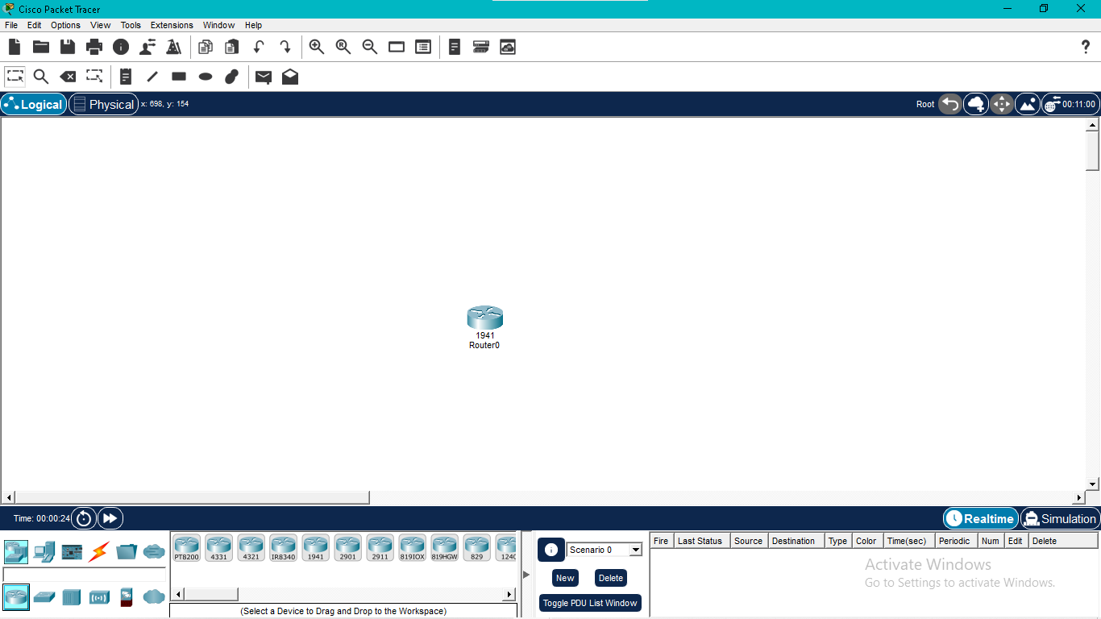

Step 2: User EXEC Mode
The router initially opens in User EXEC Mode, where only basic monitoring commands are available.
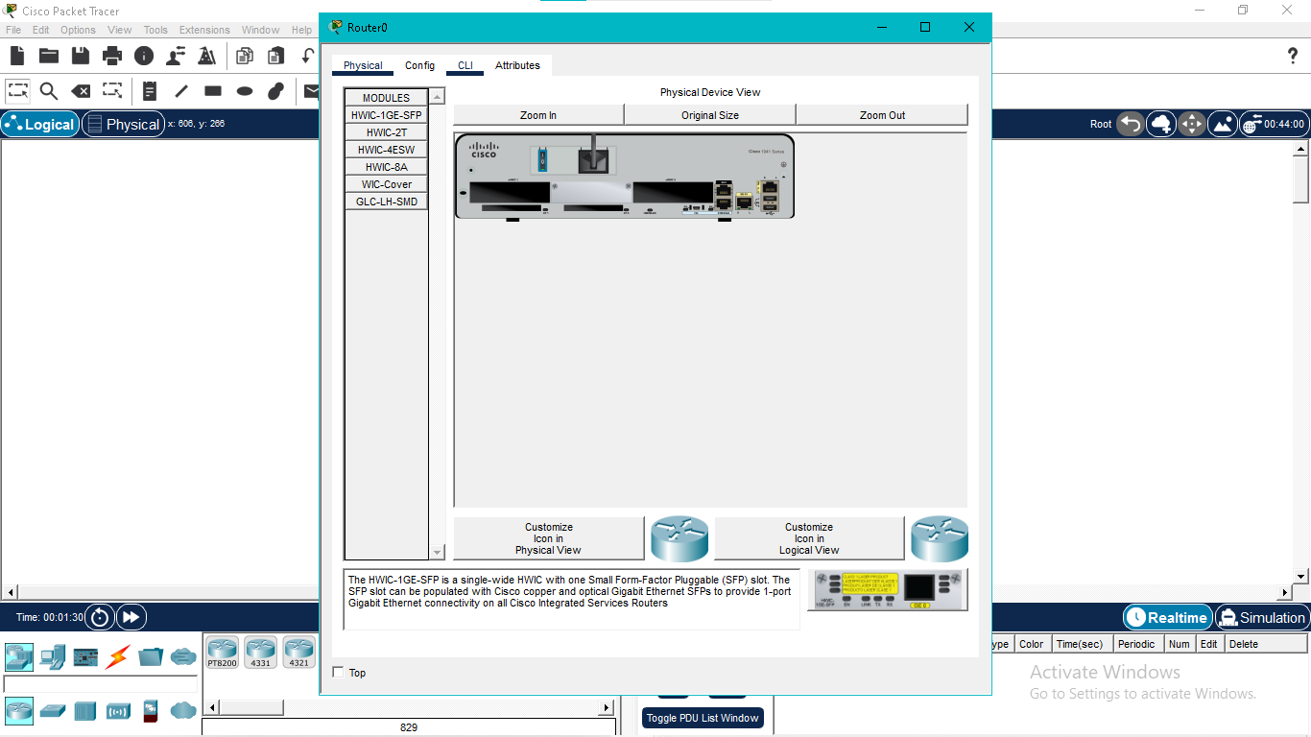

Step 3: Privileged EXEC Mode
Use the 'enable' command to access Privileged EXEC Mode, which provides administrative access.
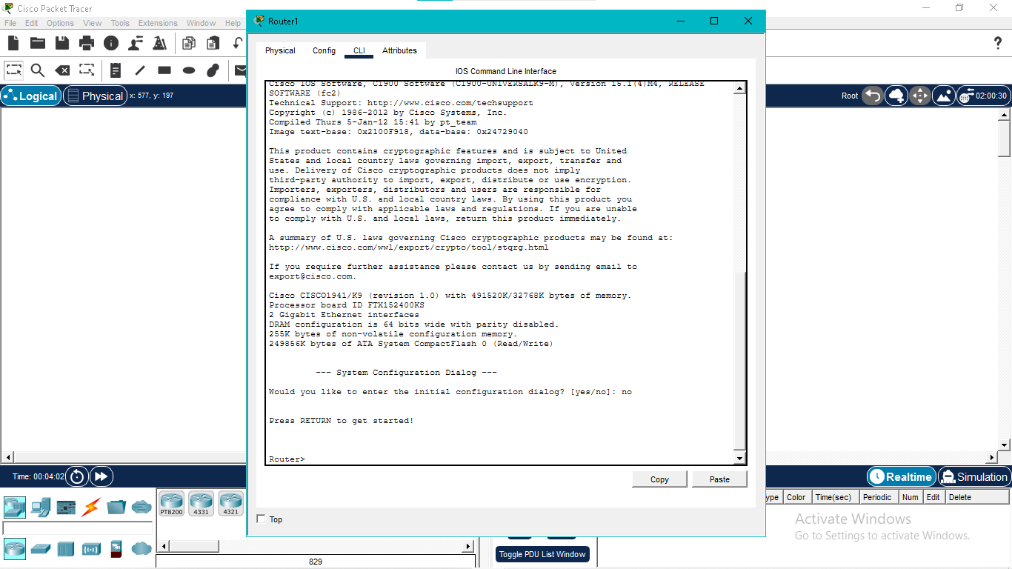

Step 4: Global Configuration Mode
Enter 'configure terminal' to modify the router's settings.
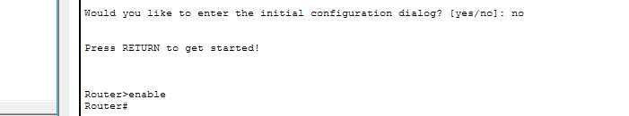

Step 5: Configure Password Security
Assign an enable password and use 'service password-encryption' to secure stored passwords.
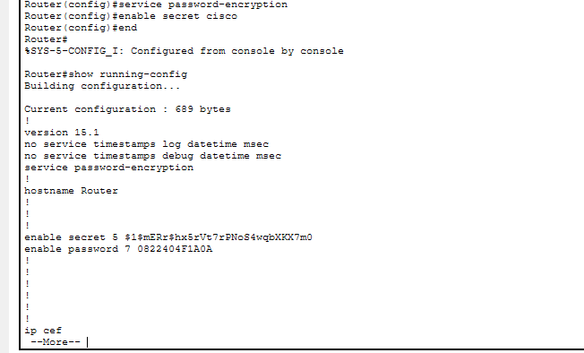
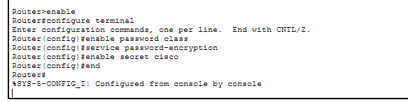

Step 6: Save Configuration
Save the running configuration to startup configuration using 'copy running-config startup-config'.
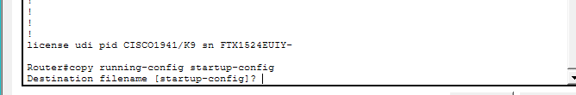

Conclusion
The router was successfully accessed, configured, secured, and the configuration was saved for future use.

